Breanos Industrial Workflow

Actual Status/Future development

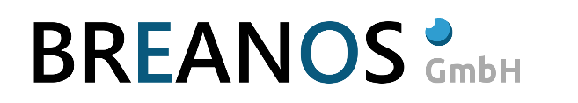

Neutorstraße 13  
5020 Salzburg

AUSTRIA

Tel: +43 (662) 276198-11

Fax: +43 (662) 276198-98

Mail: [office@breanos.com](mailto:office@breanos.com)

|  |  |
| --- | --- |
| File | Actual Status/Future development  .docx |
| Date | 11.09.2018 |

Table of contents

1 Change history 3

2 Actual State / Should State 4

2.1 Actual State 4

2.2 Should State 4

3. Supported Workflow Types 4

3.1 Sequential Workflow 4

3.1.1 Demo Workflow for a Sequential Workflow 4

3.2 Flow Chart 5

3.2.1 Demo Workflow for a Flow Chart Workflow with a if statement 5

3.2.2 Demo Workflow for a Flow Chart Workflow with a while loop statement 6

3.2.3 Demo Workflow for a Flow Chart Workflow with a switch statement 6

3.3 State Machine 7

4. Parallel workflow activites 9

5. Road map 9

# Change history

|  |  |  |  |
| --- | --- | --- | --- |
| Date | Version | Author | Description |
| 5.9.2018 | 0.1 | EBE | Initial version |
| 6.9.2018 | 0.2 | EBE | Current version |
| 7.9.2018 | 0.3 | EBE | Updated timetable |
| 10/11.9.2018 | 0.4 | EBE | Added workflow events |

# Actual State / Should State

## Actual State

The current status of the BIF project is the original Wexflow workflow modified to our needs.

* Major changes
  + Wexflow is a .Net core project now.
  + Input syntax of the Workflow xml has been changed
  + File based operations has been removed
  + Execution of the workflow has been changed to event based execution.

## Should State

* Wexflow supports a real state machine comparable to Workflow Foundation.
* Transitions can be defined like in Workflow Foundation.
* Execution of parallel Activities is possible.

# 3. Supported Workflow Types

## 3.1 Sequential Workflow

The Sequential Workflow is the initial designed Workflow type implemented in the original Wexflow implementation.

A sequential workflow is made of one or many different or same activities which are executed in sequential order.

A demo workflow looks like the following code snippet.

## 3.1.1 Demo Workflow for a Sequential Workflow

<Workflow xmlns="urn:wexflow-schema" id="3" name="Workflow_Sequencial” description="A sequencial workflow">

<Settings>

<Setting name="launchType" value="startup" /> <!-- startup|trigger|periodic -->

<Setting name="enabled" value="true" /> <!-- true|false -->

<Setting name="statemachinetype" value="DemoWorkflowState" />

</Settings>

<Activities>

<Activity id="1" name="CheckMilkExpirationDate" description="asdasd" enabled="true">

<Setting name="ParameterType" value="MilkPackageDto" />

<Setting name="ExpirationDate" value="2017-08-31T12:14:00"/>

<Setting name="MaxFillCcm" value="1000"/>

<Setting name="CurrentFillCcm" value="322"/>

<Setting name="Manufacturer" value="Landmilch"/>

<Setting name="Vendor" value="Spar GmbH"/>

</Activity>

<Activity id="2" name="BeepActivity" description="HappySuccessBeep" enabled="true">

<Setting name="ParameterType" value="BeeperParams"/>

<Setting name="Note" value="c#6" />

<Setting name="Duration" value="125" />

</Activity>

<Activity id="3" name="BeepActivity" description="HappySuccessBeep2" enabled="true">

<Setting name="ParameterType" value="BeeperParams"/>

<Setting name="Note" value="e6" />

<Setting name="Duration" value="125" />

</Activity>

<Activity id="4" name="BeepActivity" description="BadMilkBeep" enabled="true">

<Setting name="ParameterType" value="BeeperParams"/>

<Setting name="Note" value="c6" />

<Setting name="Duration" value="125" />

</Activity>

<Activity id="5" name="BeepActivity" description="BadMilkBeep2" enabled="true">

<Setting name="ParameterType" value="BeeperParams"/>

<Setting name="Note" value="d#6" />

<Setting name="Duration" value="125" />

</Activity>

<Activity id="55" name="BeepActivity" description="BadMilkBeep2" enabled="true">

<Setting name="ParameterType" value="BeeperParams"/>

<Setting name="Note" value="f#6" />

<Setting name="Duration" value="125" />

</Activity>

<Activity id="6" name="BeepActivity" description="ExceptionWarnBeep" enabled="true">

<Setting name="ParameterType" value="BeeperParams"/>

<Setting name="Note" value="d#5" />

<Setting name="Duration" value="125" />

</Activity>

<Activity id="7" name="BeepActivity" description="ExceptionWarnBeep2" enabled="true">

<Setting name="ParameterType" value="BeeperParams"/>

<Setting name="Note" value="f#5" />

<Setting name="Duration" value="125" />

</Activity>

<Activity id="8" name="BeepActivity" description="PreCheckBeep" enabled="true">

<Setting name="ParameterType" value="BeeperParams"/>

<Setting name="Note" value="a5" />

<Setting name="Duration" value="125" />

</Activity>

<Activity id="9" name="BeepActivity" description="AfterCheckBeep" enabled="true">

<Setting name="ParameterType" value="BeeperParams"/>

<Setting name="Note" value="a6" />

<Setting name="Duration" value="125" />

</Activity>

</Activities>

</Workflow>

Every activity gets executed in a sequential order starting with the first activity. Please ensure that the first activity has the Activity id of 0 because of internal purposes of the BIF Engine.The parent Workflow Id of the first Activity has to be set to -1.

## 3.2 Flow Chart

The Flow Chart Workflow is the second by original Wexflow workflow supported type. It adds 3 logical constructs to the Workflow. A if statement / while statement and switch statement.

## 3.2.1 Demo Workflow for a Flow Chart Workflow with a if statement

<Workflow xmlns="urn:wexflow-schema" id="5" name="Workflow_If" description="Workflow_If">

<Settings>

<Setting name="launchType" value="trigger" /> <!-- startup|trigger|periodic -->

<Setting name="enabled" value="true" /> <!-- true|false -->

</Settings>

<Activities>

<Activity id="1" name="IfActivity" description="If comment" enabled="true">

<Setting name="Value" value="1" />

</Activity>

<Activity id="2" name="ThenActivity" description="Then comment" enabled="true">

<Setting name="Value" value="2" />

</Activity>

<Activity id="3" name="ElseActivity" description="Else comment" enabled="true">

<Setting name="Value" value="3" />

</Activity>

</Activities>

<ActivitySetup>

<If id="100" parent="-1" if="1">

<Do>

<Activity id="2"><Parent id="-1" /></Activity>

</Do>

<Else>

<Activity id="3"><Parent id="-1" /></Activity>

</Else>

</If>

</ActivitySetup>

</Workflow>

## 3.2.2 Demo Workflow for a Flow Chart Workflow with a while loop statement

<Workflow xmlns="urn:wexflow-schema" id="5" name="Workflow_Do" description="Workflow_Do">

<Settings>

<Setting name="launchType" value="trigger" /> <!-- startup|trigger|periodic -->

<Setting name="enabled" value="true" /> <!-- true|false -->

</Settings>

<Activities>

<Activity id="1" name="BooleanActivity" description="Bool comment" enabled="true">

<Setting name="Value" value="True" />

</Activity>

<Activity id="2" name="DateTimeActivity" description="DateTime comment" enabled="true">

<Setting name="Value" value="Hello World" />

</Activity>

<Activity id="3" name="Trace" description="Trace comment" enabled="true">

<Setting name="Value" value="Hello World" />

</Activity>

</Activities>

<ActivitySetup>

<While id="100" parent="-1" while="1">

<Activity id="3"><Parent id="-1" /></Activity>

<Activity id="2"><Parent id="3" /></Activity>

</While>

</ActivitySetup>

</Workflow>

## 3.2.3 Demo Workflow for a Flow Chart Workflow with a switch statement

<Workflow xmlns="urn:wexflow-schema" id="5" name="Workflow_Switch" description="Workflow_Switch">

<Settings>

<Setting name="launchType" value="trigger" /> <!-- startup|trigger|periodic -->

<Setting name="enabled" value="true" /> <!-- true|false -->

</Settings>

<Activities>

<Activity id="1" name="StringActivity" description="Bool comment" enabled="true">

<Setting name="Value" value="Wednesday" />

</Activity>

<Activity id="2" name="DateTimeActivity" description="DateTime comment" enabled="true">

<Setting name="Value" value="Hello World" />

</Activity>

<Activity id="3" name="Trace" description="Trace comment" enabled="true">

<Setting name="Value" value="Hello World" />

</Activity>

</Activities>

<ActivitySetup>

<Switch id="100" parent="-1" switch="1">

<Case value="Monday">

<Activity id="3"><Parent id="-1" /></Activity>

</Case>

<Case value="Wednesday">

<Activity id="2"><Parent id="-1" /></Activity>

</Case>

<Default />

</Switch>

<Activity id="2"><Parent id="100" /></Activity>

</ActivitySetup>

</Workflow>

## 3.3 State Machine

The state machine workflow will be the first real extension to the original Wexflow workflow definition. It has the possibility to define a real state machine with states and transitions.

The first part of the Workflow definition is similar to the Sequential workflow and Flowchart definition.

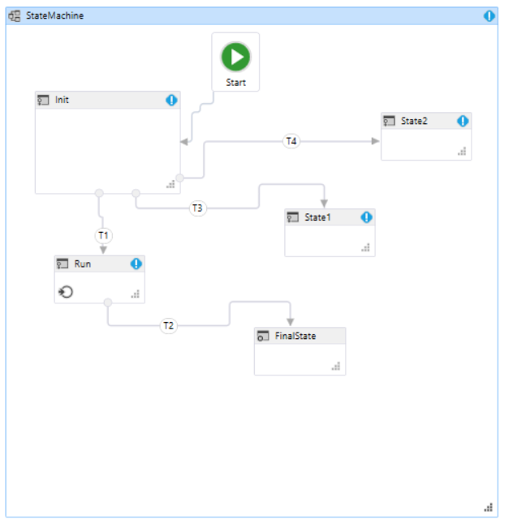

Example Workflow 1

<Workflow xmlns="urn:wexflow-schema" id="3" name="Workflow_Statemachine" description="A statemachine workflow">

<Settings>

<Setting name="launchType" value="startup" /> <!-- startup|trigger|periodic -->

<Setting name="enabled" value="true" /> <!-- true|false -->

<Setting name="statemachinetype" value="DemoWorkflowState" />

</Settings>

<Activities>

<Activity id="1" name="CheckMilkExpirationDate" description="asdasd" enabled="true">

<Setting name="ParameterType" value="MilkPackageDto" />

<Setting name="ExpirationDate" value="2017-08-31T12:14:00"/>

<Setting name="MaxFillCcm" value="1000"/>

<Setting name="CurrentFillCcm" value="322"/>

<Setting name="Manufacturer" value="Landmilch"/>

<Setting name="Vendor" value="Spar GmbH"/>

</Activity>

<Activity id="2" name="BeepActivity" description="HappySuccessBeep" enabled="true">

<Setting name="ParameterType" value="BeeperParams"/>

<Setting name="Note" value="c#6" />

<Setting name="Duration" value="125" />

</Activity>

<Activity id="3" name="BeepActivity" description="HappySuccessBeep2" enabled="true">

<Setting name="ParameterType" value="BeeperParams"/>

<Setting name="Note" value="e6" />

<Setting name="Duration" value="125" />

</Activity>

</Activities>

<StateDefinition>

<State id=”1” name=”Init” description=”My Init state” entryId=”” exitId=””>

<Transition name=”T1” condition=”x == 1” description=”T1 tran.” destId=”2” triggerActId=”” conditionActId=””/>

<Transition name=”T3” condition=”x == 2” description=”T3 tran.” destId=”3” triggerActId=”” conditionActId=””/>

<Transition name=”T4” condition=”x == 3” description=”T4 tran.” destId=”4” triggerActId=”” conditionActId=””/>

</State>

<State id=”2” name=”Run” description=”My Run state” entryId=”” exitId=””>

<Transition name=”T2” condition=”x == 0” description=” T2 tran.” destId=”2” triggerActId=”” conditionActId=””/>

</State>

<State id=”3” name=”State1” description=”My State1 state” entryId=”” exitId=””/>

<State id=”4” name=”State2” description=”My State2 state” entryId=”” exitId=””/>

<State id=”5” name=”FinalState” description=”My FinalState state” entryId=”” exitId=””/>

</StateDefinition>

## 4. Parallel workflow activites

Wexflow doesn’t support parallel execution of activities.

The current prototype of BIF cheekily disables the parallel-check via check which would work by searching for activity nodes with equal predecessor (parent) which would indicate parallel execution.

Not being considered so far is the fact that multiple running activities might mutually destroy the common state-object / information-exchange-object (comp. DTO for communication between activities) and there are no synchronization safeguards in place to prevent that.

Suggestion:

Activities always use a copy of the state object. if there’s members in there that can intrinsically handle multiple accessing activities like for instance an AmqConnector, (which can have a multitude of listeners for its Message event) its trivial to simply copy the reference to that object into the state-object-copy.

All running activity-tasks (System.Threading.Tasks.Task) are added to a dictionary with the key being the Activity’s id Synchronization then happens via a new node type of the ActivitySetup wich brashly either

references an activity which handles synchronization

has some settings which more generically define synchronization like for instance: <Setting name="SynchronizationType" value="FirstWins" /> /// or /// <Setting name="SynchronizationType" value="AggregateSum">,<Setting name="SumParameter" value="MyDtoProperty1" />,...

Statemachine-wise, as far as we know you cannot run multiple transitions in parallel that would lead to different states.

Again, parallel running activities in state machines would have to be synchronized somehow, possibly through a wrapper-activity like suggestion a) for flowchart activities (see above) or maybe activity-intrinsic programming.

## Road map

The implementation effort is estimated as follows.

|  |  |
| --- | --- |
| Task | Available Severity |
| State machine | 28.9.2018 Middle |
| Extended parser | 7.9.2018-12.9.2018 Easy |
| Extended execution engine with events | 13.9.2018-19.9.2018 Middle-Heavy |
| Transitions | 20.9.2018-28.9.2018 Middle-Easy |
| Guards/Boolean expressions | 20.9.2018-28.9.2018 Easy |
| Parallel execution for state machine | 1.10.2018-12.10.2018 Heavy |

## How to design a custom Activity

A wexflow activity is a separate dll which implements a class derived from Activity or StatefulActivity.

CWF Engine loads all Activity dlls original located in the folder C:\Wexflow\Activities.

The method run gets invoked by the CWF Engine and executed as separate Task.



The name convention for the dll is CWF.Tasks.”Name of Activity” and the run method gets called by the CWFEngine.

Run method parameters:

public override void Run(Node n, object state, object parameterDto)

Node n … current Node.

Object state … passes the state object. (Success, Warning, Error)

Object parameterDto … the Parameter DTO which was parsed from the workflow definition.

## Workflow Events

Breanos Workflow has the possibility to send and receive Events between workflow Activities or States.

To ensure this functionality it must be a possibility to do that.